**CIMI Agenda and Minutes**

**April 21, 2016**

**Co-Chairs:**

* **Linda Bird BIT PhD,** IHTSDO, [lbi@ihtsdo.org](mailto:lbi@ihtsdo.org)
* **Galen Mulrooney MBA,** U.S. Department of Veterans Affairs, Phone: USA +1 703-815-0900, [galen.mulrooney@jpsys.com](mailto:galen.mulrooney@jpsys.com)
* **Harold Solbrig,** Mayo Clinic, [solbrig.harold@mayo.edu](mailto:solbrig.harold@mayo.edu)
* **Stanley Huff MD,** Intermountain Healthcare, Phone: USA +1 801-507-9111  
  [stan.huff@imail.org](mailto:stan.huff@imail.org)

  The “CIMI Practitioners Guide to HIE Interoperability” is being developed by the CIMI workgroup. This document is typically versioned each Monday to incorporate the previous Thursday’s CIMI WG telecom technical discussions.  The current MS Word version is always available at: <http://1drv.ms/1TuV8PD>

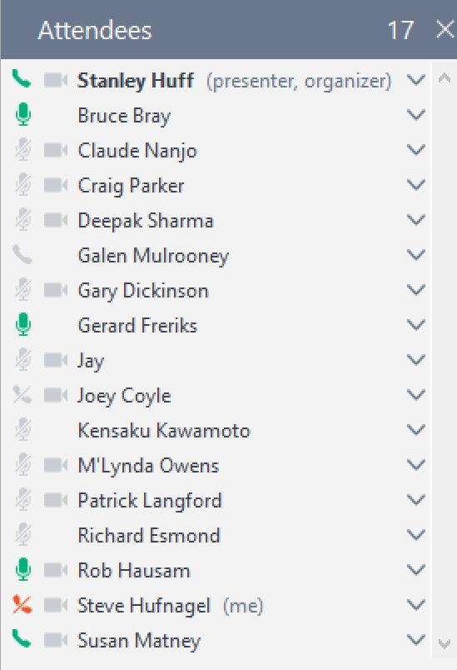

**Telecom:** Thursday US time, Friday Australia will be at 20:00 UTC.

<https://global.gotomeeting.com/join/754419973>  
  
**You can also dial in using your phone.**

United States : +1 (224) 501-3316  
Access Code: 754-419-973

**More phone numbers**

Australia : +61 2 8355 1034  
Belgium : +32 (0) 28 93 7002  
Canada : +1 (647) 497-9372  
Denmark : +45 89 88 03 61  
Netherlands : +31 (0) 208 084 055  
New Zealand : +64 4 974 7243  
Spain : +34 932 20 0506  
Sweden : +46 (0) 853 527 818  
United Kingdom : +44 (0) 330 221 0098

Annotated Agenda:

* Agenda review
* Upcoming meeting schedule
  + April 28
    - Join the Unified FHIR Clinical Data Model Discussion? – Grahame and Ewout presentation to ONC
      * Stan to send out invitation
  + May 5
    - SNOMED CT model meaning bindings to FHIR resources – Linda and Harold
    - Question from HL7 TQA team: Could we have Harold’s tool export MIF along with RF2?
* Update and approval of FHIM – CIMI Task Force
  + Steve Hufnagel, Jay Lyle, Claude Nanjo, Linda Bird, Rob Bishop, Stan Huff, Galen Mulrooney
    - Stan to set up one or more meetings to work on this
* Proposed agenda for Montreal – All
  + Block outline of CIMI sessions in Montreal (see attachment)
  + Any additional items?
  + Slotting the topics into quarters – Jay will do, and send out for comments
* FHIR proposed Vital Signs panel
  + Additional discussion needed?
  + see <http://argonautwiki.hl7.org/index.php?title=Vital_Signs>
  + We think the FHIR proposed model looks pretty good – need to check on the panel level LOINC code
    - Subtype of CIMI
  + We need to ask an openEHR expert about the exact meaning of the vital signs archetypes.
* Would CIMI be willing to host other artifacts? – Claude
  + Order sets, rules, documentation templates, etc.
  + These activities are tightly coupled to CIMI models
  + We will do rules and other artifacts as appropriate as a joint activity with the CDS WG – Approved by consensus
  + Richard can help develop a POC of this activity
* Prioritize topics for upcoming meetings – Stan
* Talk about impedance mismatch - Richard Esmond
  + Richard sent an email giving further description of this topic. (see attached email)
* Future topics
  + IHTSDO work for binding SNOMED CT to FHIR resources – Linda, Harold
  + Continued work on the preferred model for Problems/Health Issues - Stan
  + Which openEHR archetypes should we consider converting to CIMI models?
  + Model approval process
  + Model transformations
  + What models do we want to ballot?
  + Semantic terminology bindings at the level of the whole model
    - Is it correct to bind “id” nodes to terminologies without going through an “at” node?
    - Test code should be bound to LOINC; should the root also?
  + Should we have a template level of models for CIMI as patterned on openEHR processes?
  + Transform of ICD-10 CM to CIMI models – Richard
  + Others?
* Any other business

NO CIMI Meeting on Apr 28, 2016, due to ONC meeting

**Unified FHIR Clinical Data Model Meeting Agenda**

**Thursday, April 28, 2016, 3:00 p.m. – 5:00 p.m., Switzer Building, Conference Room 2201**

**External Attendees:** Grahame Grieve, Rien Wetheim, Ewout Kramer, Dragan Bashyam, Johnathan Coleman, Mike Flanigan, Floyd Eisenberg (Virtual) , Ed Hammond (Virtual), Galen Mulrooney (Virtual), Kensaku Kawamoto (Virtual), Stan Huff (Virtual), Claude Nanjo (Virtual), Bryn Rhodes (Virtual),

**ONC Attendees:** Steve Posnack, Kelly Cronin, Alicia Morton (Virtual), John Snyder, Chris Muir, Gail Kalbfleisch, Julia Skapik, Adam Culbertson, Matt Rahn, Alex Baker, Tracy Okubo

**Proposed Agenda/Update Items**

**Facilitator: Johnathan Coleman**

1. Introductions (All)
2. Recap and Status (Johnathan)
3. FHIR common data elements and Data Modeling/Mapping (in relation to Dr. Hammond’s proposal from HL7) (Grahame/Ed Hammond)
4. Native FHIR data model (Grahame)
5. Unified FHIR Clinical Data Model—QICore/QUICK (Julia)

